

# Test Automation

**Experiment 3**

**Submitted by :** **Submitted to :**

**Rahul Gusain**   **Mr. Alind A**

Step 1: - Write the below commands in the terminal or paste the below commands in the terminal to create the spyder directory. It will contain some more files as shown in screenshot which is automatically being created by the scrapy.

Command: - **scrapy startproject spyder**

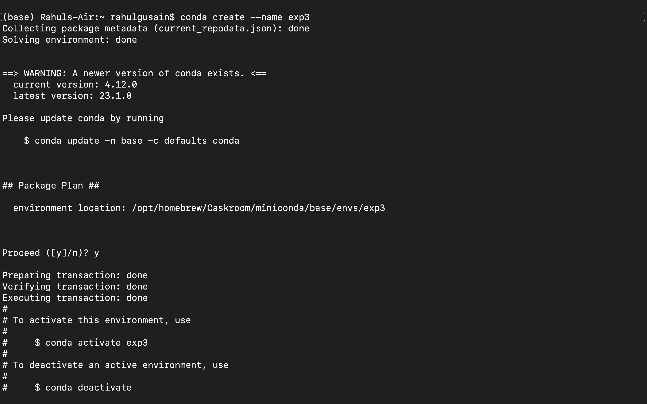

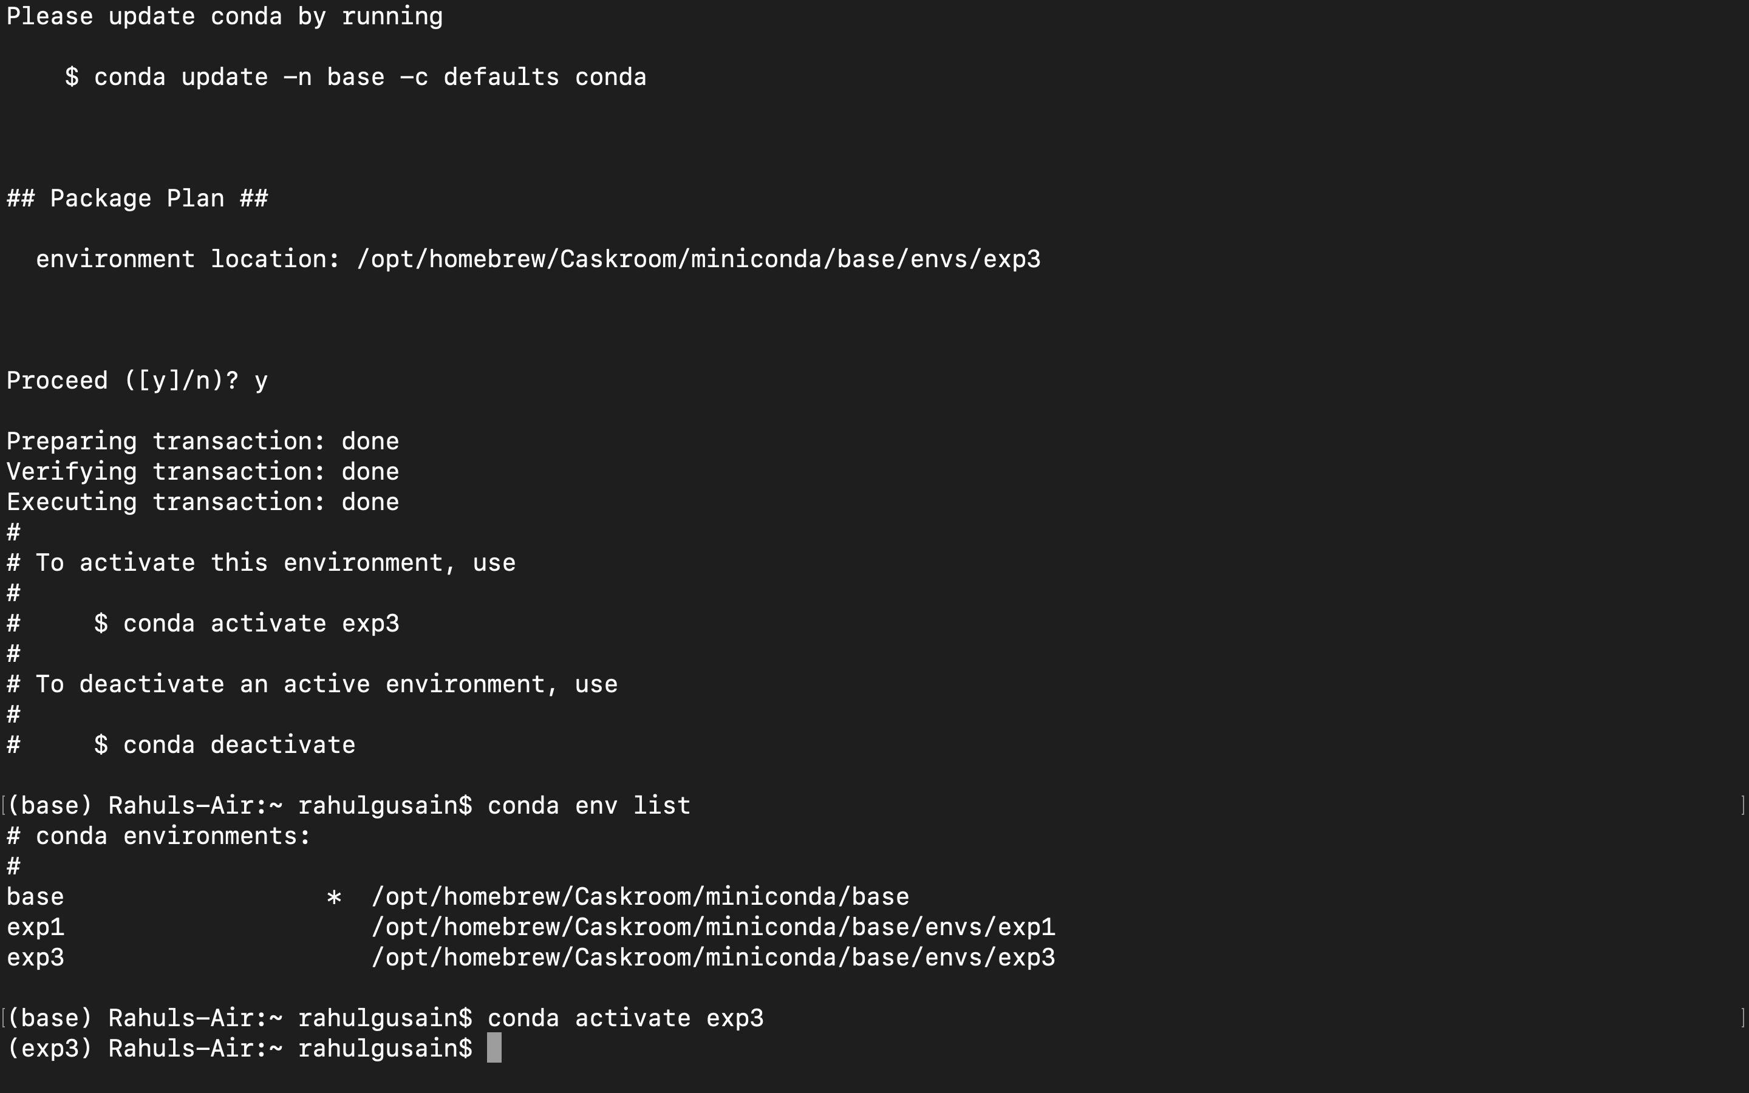

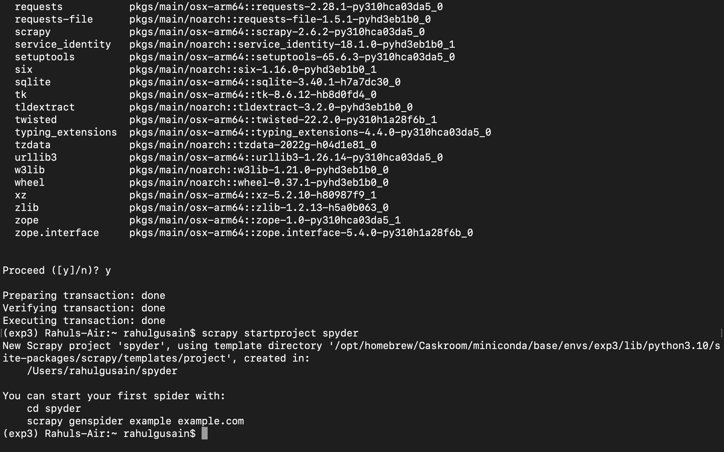

Step 2: - Now we will create our first spider. To do that we need to create a python file named quotes_spider.py in spyder/spyder/spiders directory.

Command: - **cd spyder/spiders**



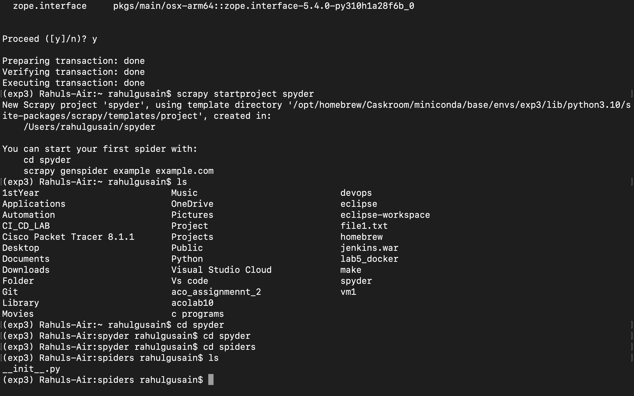

Command: - **touch quotes_spider.py**

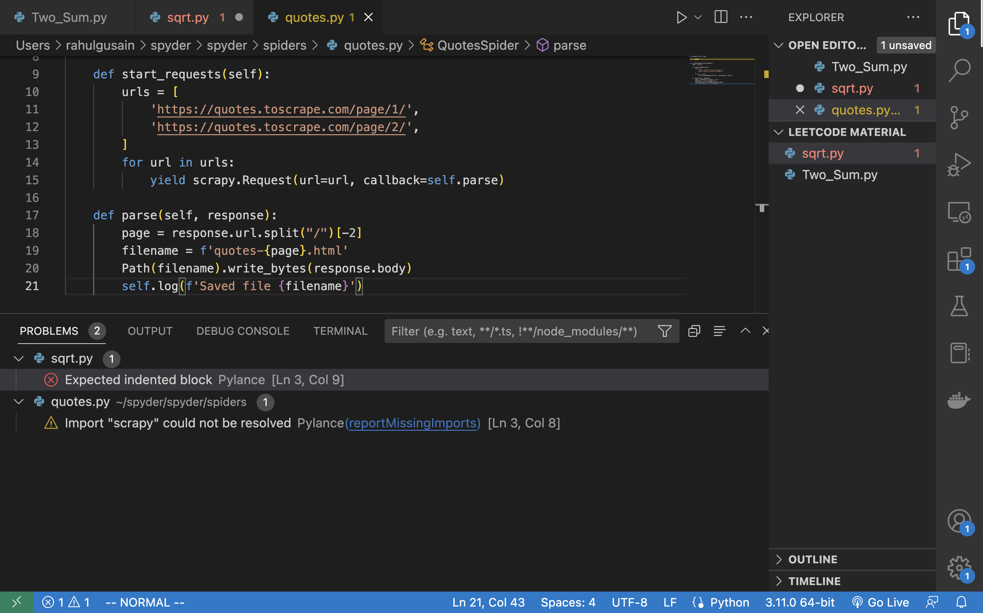

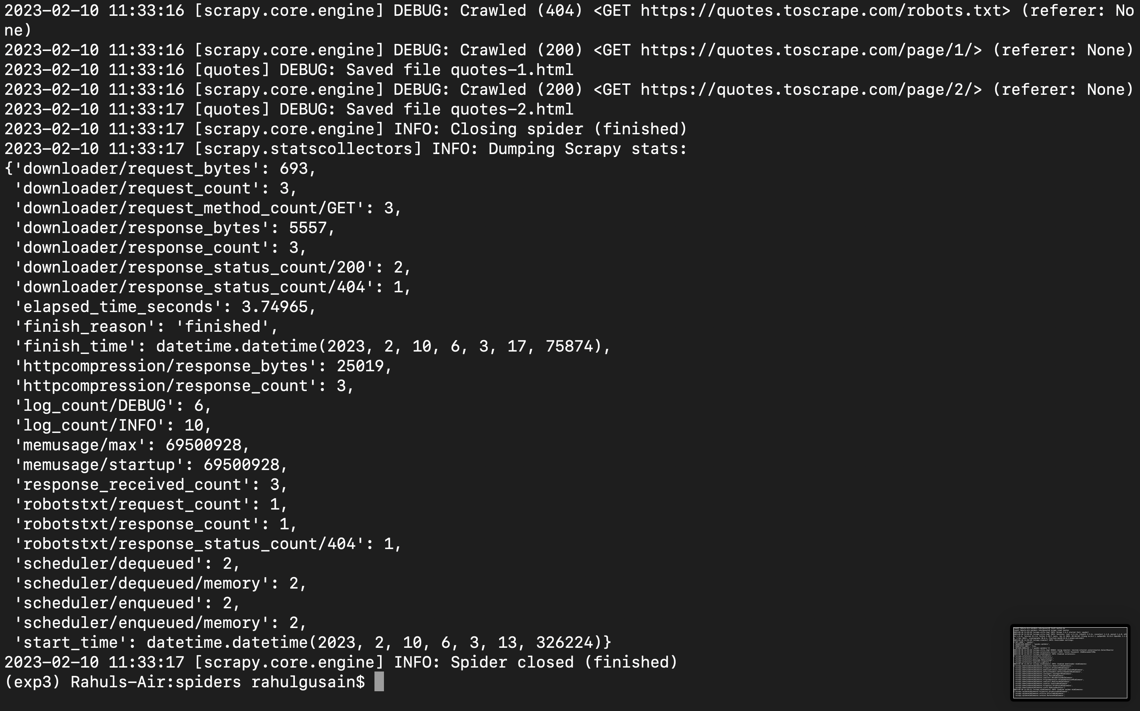

Step 3: - Now we will store the scrapped data into json file and csv file. For that we need to execute the below command.

Command: - **scrapy crawl quotes -O quotes.json**

Command: - **scrapy crawl quotes -O quotes.csv**

